Rome was not built in a day — similarly the Bridge to World Understanding is gradually taking form with each participant adding to its strength and importance.

Countries currently setting up committees for this project and looking to see how much they can contribute include:
Argentina ‡
Australia
Barbados
Brazil
Egypt
India*
Ivory Coast
Italy
Japan
Mallorca
Mexico ‡
Phillipines
Singapore*
Taiwan*
United Kingdom
United States*

The countries on this list have expressed interest in the project. Not all countries have confirmed participation as of the printing of this flyer.
* As of this flyer have confirmed students have access to e-mail
‡ As of this flyer have only confirmed snail mail

North (San Diego) County Inland Rotaract
Rotaract@san.rr.com
Who to contact for more information:

You can e-mail either of the NCI Rotaract
Bridge to World Understanding Co-Chairs.

Anna Goldby Agoldby@aol.com

Or

Ryan Barker Barker@aznet.net

Or you can join the international mailing list for this project and talk to Rotaractors from around the world about what we are doing. To do so please sign up at:
http://Rotaract_Bridge.listbot.com
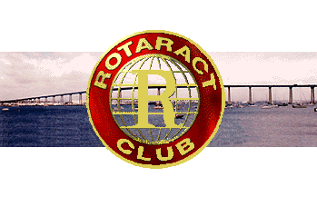

To find out more about the Bridge to World Understanding, please visit the NCI Rotaract Club website at http://www.rotaract.org/nci-rotaract
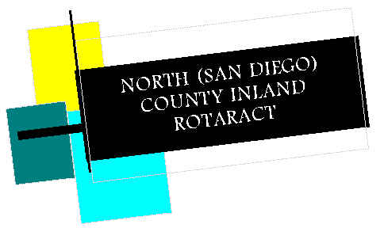

The North County Inland Rotaract Club, in an effort to foster International Understanding & promote the development of language skills, presents

“A Bridge to World Understanding.”

The many ways in which a
person can participate

The foundation for the “Bridge to World Understanding” project is being built by Rotaract Clubs around the world.

This foundation is designed to support any of several possibilities for the students to choose from. It is our hope that they will find one of the possibilities both fun & exciting — or will find a variation that will suit their personalities & interest.

The first step for any “Bridge to World Understanding” project is to find a country in which they are interested. (We suggest picking several countries, & writing to each. We can not guarantee a response to each letter but want to give them as many chances as possible to receive a reply!)

Once a country is picked, the student needs to decide which of the possible projects they want to do.
- Write a short story that takes place in another country
- Design a webpage
- A day in another country
- Short story in another country with pictures found on the web, and sounds
- Write to a student in a country that serves as the setting of a story read in class and find out if natives think it is true to life, or has poetic license been taken? (Is America like Huck Finn? The Great Gatsby?)
- E-mail two or three times a week to a student in the country of choice and find out about the issues in their lives, and write a short story about going to visit them. (Are there gangs in India?)
- Find out about their concerns about coming to visit you, and write a short story about your new friend coming for a short visit.
What we would like...

The local Rotaract Club’s would like to share in the excitement and fun!

NCI Rotaract will post links to the web page projects. In addition, it is our hope that as many of the essays as possible will end up on the web.

Local Rotaract Clubs have the opportunity to make a local community service project out of helping any students who can type their stories up and e-mail them to the club. The local Rotaract club can then post these essays on the web and send the URL to NCI Rotaract.

The sponsoring Rotaract Club’s would like to receive something from the classes involved at the end of the project. We would like them to share with us what came of the experience. A thank you letter in which each student writes a few sentences about what they learned — or a “bound collection” of essays we could read!

Why a “Bridge to
World Understanding?”

Rotaract is a community service and professional development club for 18-30 year old men and women who want to contribute to the local and international communities. This project came out of a conversation in which club members shared their desire to help kids in our own community, and those overseas. We wished students could write to kids abroad and find out about their lives and what they need. From there it was a short leap to realize this was a project we wanted to share with the local schools, helping students to find out how similar we are — helping build a bridge to world understanding!

