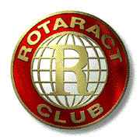

North County Inland Rotaract
Post Office Box 502582
San Diego, CA 92150-2582

E-Mail: Rotaract@san.rr.com

June 1, 1999

To Whom It May Concern:

The North County Inland Rotaract Club, a local club sponsored by Rotary International, is putting together care packages for Kosovar refugees and would greatly appreciate any donations you could contribute towards this project.

Our hope is to put together as many shoebox size packages as possibly containing both daily needs and something that offers hope for the future. Perhaps a postcard of a San Diego scene taped to the top of the box.

For your information, our Rotaract Club joins 6,000 others in over 120 countries and geographic regions, as a community service organization for 18 - 30 year old men and women that also provides leadership and professional development opportunities.

We are pleased to be part of a group that defines the community as the city in which we live, the region in which we live, the country in which we live, and the planet on which we live. As such we are both able and in fact encouraged to do local and international community service projects.

Thank you in advance for your time and kind support.

Sincerely,

Member of North County Inland Rotaract Club

